**Practical No: 11**

**Aim :** To create tweening animation for bouncing boll using flash animation.

**Performed By :**

**Class :** BCA-III SEM-V

**Date :** 07/10/2024

**Original Image:**

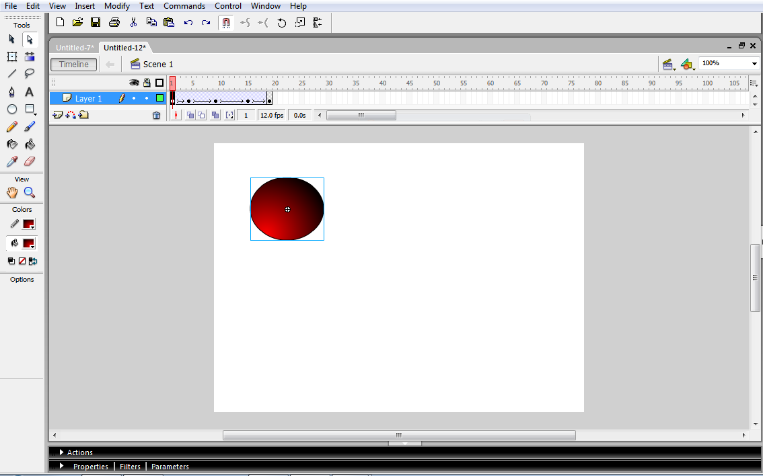

**Animated Images:**

